Lab #3
Multiple Regression
Copy and paste any results onto this page to hand in.

- Finding estimates of B using matrix command in SPSS
  - Open SPSS and go to File -> New -> Syntax
  - Type into the window (anything after the # doesn’t need to be typed):

COMMENT Estimating Bs using the Moore-Penrose Pseudo Inverse, assumes IID (does not account for #dependencies in the Xs).

get file='C:\Temp\social2.sav'.
Comment set above to whatever folder you have the "social2.sav" saved in.

matrix.
get x /variables=ciccomp oocomp.

get y /variables= qdicomp.

compute invx=(inv(t(x)*(x))) * t(x)).

compute b=(invx * y).
print b.

end matrix.
  - Copy and paste the b values below and tell me what they mean (consider first 2 lines in syntax).
.2820362148
.1302770591
They are relationships between each x and y. For a 1 unit increase in X1, y increases by .28 and as X2 increases by 1, y increases by .13. They are over estimated because the Moore-Penrose approach is treating them as independent (orthogonal) when there is a slight dependency. When they are ran through SPSS the values are .187 and .077 (a little smaller when controlled for their correlation).
- Standard regression in ARC (in forclass data n=neuroticism, e=extroversion, o=openness, a=agreeableness, c=conscientiousness, ego=egotism, sos=sexual opinion scale and soitot=sexual openness and intimacy)
  - Simple regression
    - Using the forclass.lsp data, plot SOS (H) versus SOI (V), set OLS = 1. Click on the arrow next to OLS and choose display regression summary. Look back at the original ARC window and interpret the results.
LS regression summary for [Plot2]Forclass:V:soitot H:sos
Response = soitot
Coefficient Estimates
Label Estimate Std. Error t-value p-value
Constant -1.86162 0.205515 -9.058 0.0000
sos^1 0.0250756 0.00269860 9.292 0.0000

R Squared: 0.232515
Scale factor: 0.890436
Number of cases: 287
Degrees of freedom: 285

Summary Analysis of Variance Table
Source df SS MS F p-value
Regression 1 68.4591 68.4591 86.34 0.0000
Residual 285 225.97 0.792876
Lack of fit 77 66.2655 0.86059 1.12 0.2619
Pure Error 208 159.704 0.767808
    - Click on display summaries in the “Forclass” menu to obtain descriptives and the correlation between SOS and SOI
Data set = Forclass, Sample Correlations
sos 1.0000 0.4822
soitot 0.4822 1.0000
sos soitot
  - Muliple Regression
    - Using forclass.lsp still click on Graph and Fit -> Fit linear LS. Move a, e and sos over to predictors and soitot over to response and click on OK. Back to the original ARC window and interpret results.
Data set = Forclass, Name of Fit = L1
Normal Regression
Kernel mean function = Identity
Response = soitot
Terms = (a e sos)
Coefficient Estimates
Label Estimate Std. Error t-value p-value
Constant -1.74676 0.543001 -3.217 0.0014
a -0.0251484 0.00846596 -2.971 0.0032
e 0.0270824 0.00981833 2.758 0.0062
sos 0.0228383 0.00271460 8.413 0.0000

R Squared: 0.269142
Sigma hat: 0.871993
Number of cases: 287
Degrees of freedom: 283

Summary Analysis of Variance Table
Source df SS MS F p-value
Regression 3 79.2432 26.4144 34.74 0.0000
Residual 283 215.185 0.760372
Lack of fit 281 214.26 0.762491 1.65 0.4543
Pure Error 2 0.925528 0.462764
    - Click on display summaries in the “forclass” menu to obtain correlations for a, e, sos and soitot. Do any of the correlations indicate multicollinearity, why or why not?
Data set = Forclass, Sample Correlations
a 1.0000 0.1387 -0.1988 -0.2235
e 0.1387 1.0000 0.0843 0.1579
sos -0.1988 0.0843 1.0000 0.4822
soitot -0.2235 0.1579 0.4822 1.0000
a e sos soitot
None of the correlations exceed even .5 so no multicollinearity
    - Go to graph and fit -> Multipanel plot. Put a, e, and sos into changing axis and residuals into fixed axis. Does there seem to be a problem with heteroskedasticity on any of the variables? Explain.
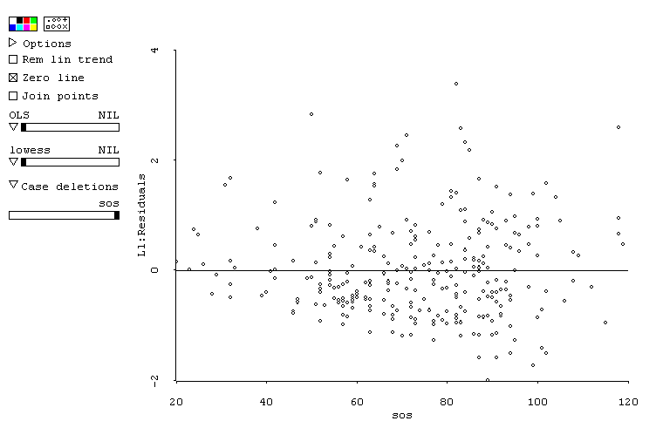
This is a repeat from before but sos predicting soitot does seem to be a little heteroskedastic because the residuals appear to be truncated at low levels of sos. The bottom left of the graph shows that you don’t have as many negative residuals at low sos values.
- Standard Regression in SPSS
  - Open up the forclass.sav data set in SPSS. Go to Analyze -> Regression -> Linear. Give me a, e, and sos predicting soitot. Include estimates, model fit, r squared change, descriptives, part and partial correlations, collinearity diagnostics, a plot of zpred (x) and zresid (y), and save mahalanobis distances. Interpret and annotate the output.

output for lab 3 question 3

Charts

yes the output is the same as the ARC output.
  - Compare the output to the output from ARC. Expect there to be a little difference because they use different estimation methods, but are the two outputs similar?
- Do a user defined sequential analysis using the block function, predicting soitot by a, e and sos. The order should be a, e and sos, include r-square change and interpret results.
- Do a forward statistical regression and include a, e and sos (include r-squared change) predicting soitot. Interpret results and compare them to the previous result (#4).
Regression

- Do a stepwise regression including sos, ego, n, e, o, a and c predicting soitot. Include estimates, model fit, r squared change, descriptives, part and partial correlations, collinearity diagnostics, a plot of zpred (x) and zresid (y), and save mahalanobis distances. Interpret and annotate the output.
Regression

Charts

- Still using the forclass.sav data go to Data -> Select Cases -> Random Sample of Cases -> Sample. Choose approximately 50%. Continue -> OK. Go to transform -> Compute. Put in set=filter_$. Fit a simultaneous regression with a, e, and sos predicting soitot. Go back to Data -> select cases -> If condition satisfied -> If. Type in set = 0. Fit the exact same regression equation and compare the two outputs. Are the two outputs the same? Can you generalize the equation?
Regression for the first half

Regression for second half

When I did it I got slightly different R-squared values which says the equation may not generalize and the regression coefficients are different for the two models which also says it may not generalize.
- Centering and Interactions. Open social2.sav in SPSS.
  - Recode gender so that males = 0 and females = 1.
  - Center both ciccomp and oocomp separately (ciccent and oocent)
  - Predict oocent with gender and ciccent and interpret results (don’t forget to interpret the intercept since it is meaningful).

  - Cross multiply gender (0 and 1) and ciccent to make a new variable gen_cic.
  - Predict oocent by gender (0 and 1), ciccent and gen_cic. Interpret the results.
Regression

- Mediation using regression. Open social2.sav in SPSS and perform a mediational analysis using oocomp as the predictor, ciccomp as the mediator and qdicomp as the outcome. Interpret the results. Refer to the four steps from the powerpoint slides.
Regression
Regression
Regression

- In the social2 data set the variables are:
1 | ciccomp | classroom interracial climate
2 | qdicomp | discrimination index
3 | srchcomp | ethnic identity search
4 | eicomp | ethinic identity strength
5 | subcomp | subgroup identity
6 | oocomp | outgroup orientation
7 | supcomp | superordinate identity

- Think of a possible hypothesis for how these variables might predict one another (e.g. pick a DV and a few IVs and make up a reason why they might be related) in a use defined sequential regression analysis.
- Perform all appropriate tests on the variables (assumptions, transformations when needed,etc).
- Perform the sequential analysis using SPSS. Interpret the results
- On a separate sheet of paper write the hypothesis in a couple of sentences max and then write an APA style results section summarizing your results (refer to the end of chapter 5 for a couple of samples). Make sure to write the results so that anyone reading it can understand it (make it as clear as possible and in very simple language, explaining all technical terms).
This answer is different for everyone so there is no real way to answer it here.

